Exhibit Materials available - order 4 weeks prior to the event
Email the completed order form to Hannah Mueller at hmueller@techforce.org

Downloadable School Resource Kits available for Instructors & Counselors
https://techforce.org/resources/

▢ Banner Stand - $250 (+ shipping)
6’ portable, retractable banner free-standing.
Available to order/dropship.
Quantity: _____________

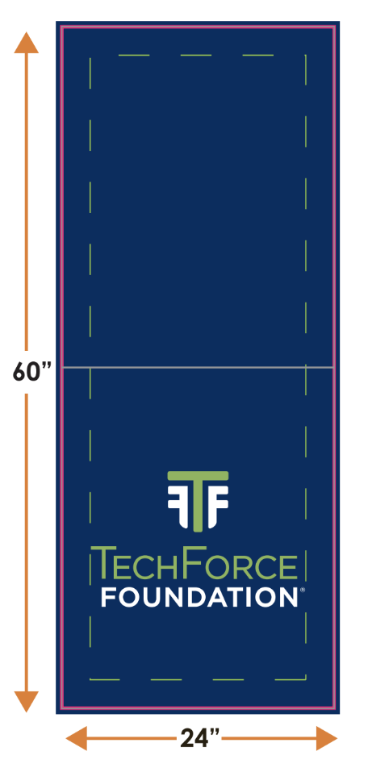
▢ Table Runner - $22.55 (free shipping)
24” x 60” tablecloth cover to add TechForce branding to a trade show table. Available to order/dropship.
Quantity: _____________

▢ 2” x 2” Info Card
Double-sided informative cards with QR code.
Quantity: _____________ (minimum 100: $41)

▢ Fist Design 2” x 2” Stickers
Quantity: _____________ (minimum 10 for $9) or
▢ Place own order

▢ TechForce Badge 2” x 2” Stickers
Quantity: _____________ (minimum 10 for $9) or
▢ Place own order

▢ Sticker Sheet
Quantity: _____________ (minimum 10 for $40) or
▢ Place own order

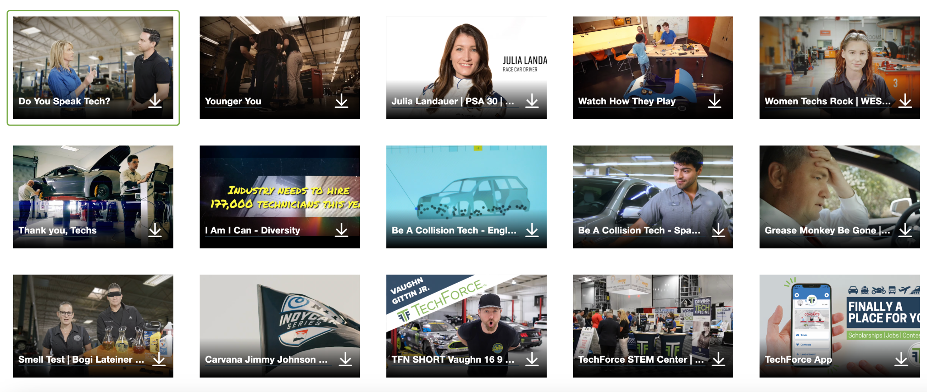
Downloadable videos
“Presentations Showcase” videos are available for download on Vimeo, covering various topics. Loop reel available.
▢ Rack Cards
Brochure-sized double-sided informational cards
Quantity: _____________ (minimum 50 for $32)

▢ Counter Cards
8.5”x 11” single-sided informational cards
Quantity: _____________ (minimum 50 for $38)

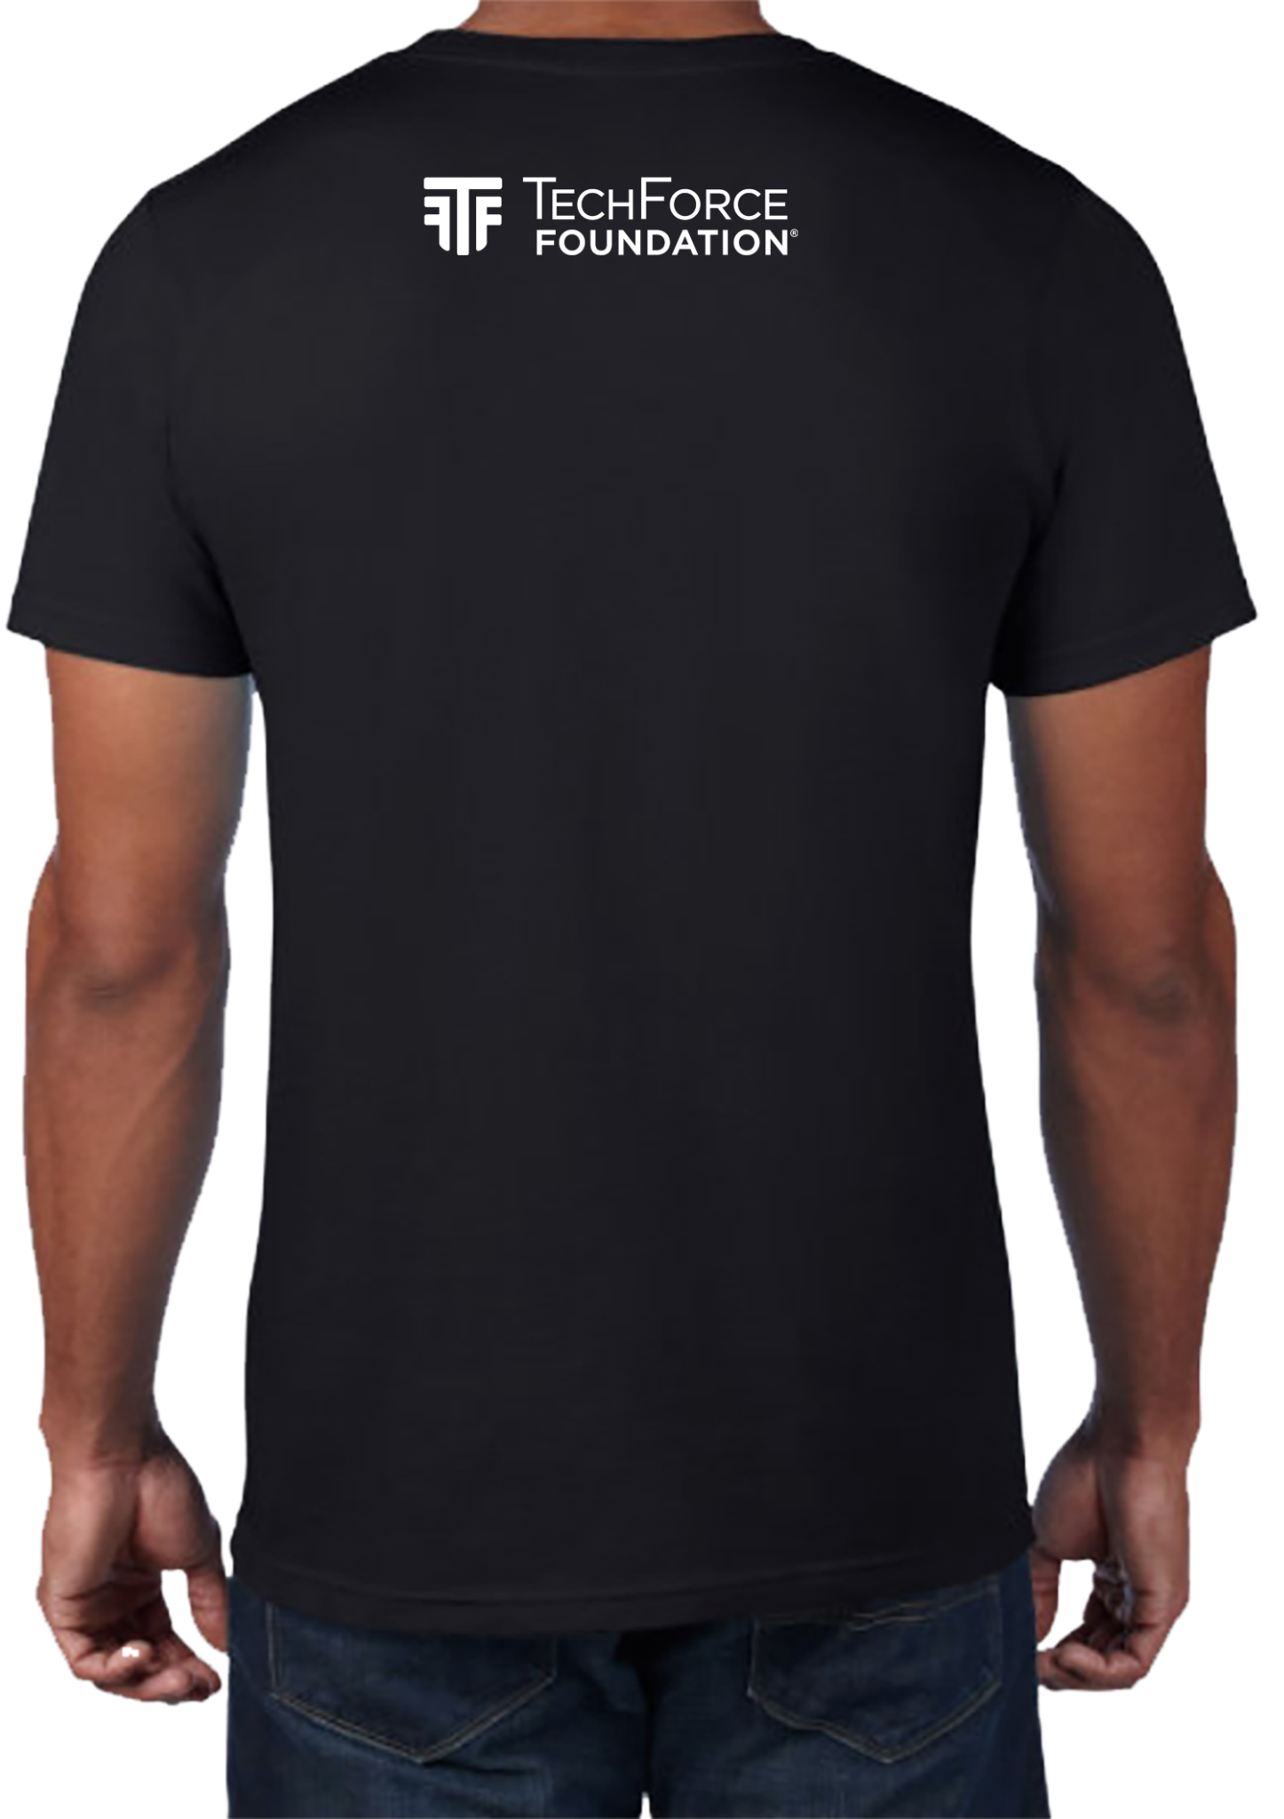
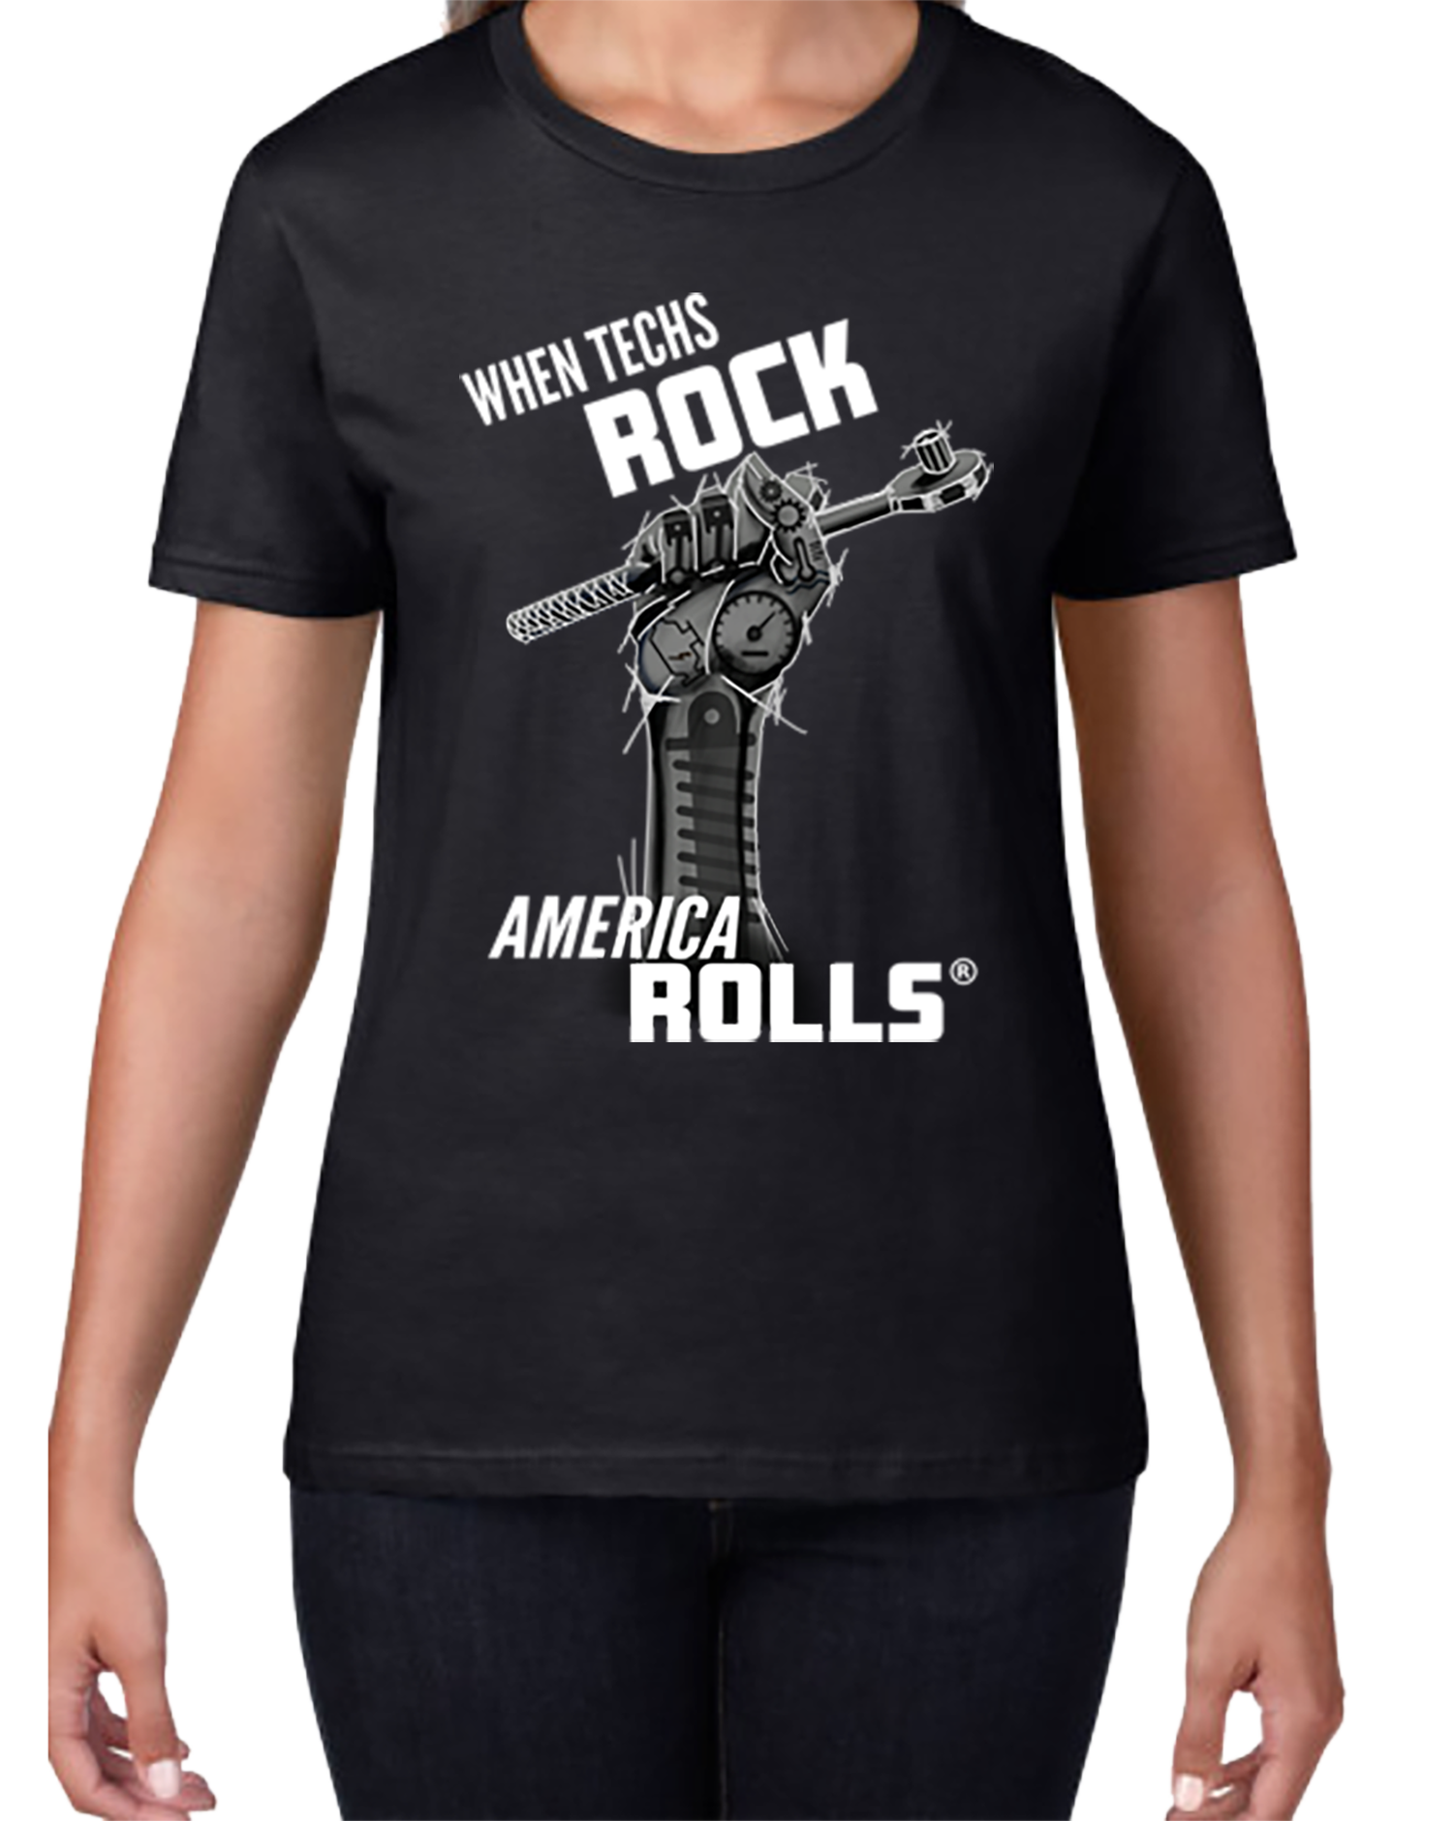
▢ Apparel
When Techs Rock, America Rolls T-shirt download print artwork in resources
Other apparel add TF Logo via Lands End Business Store
https://business.landsend.com/store/techforce/

Deliverables to:
Name: ________________________________________________
Company Name: ________________________________________________
Address: ________________________________________________
________________________________________________
Phone: ______________________________

Note: Order minimums, shipping fees, and prices are subject to change. SG 240206

